## JAYPEE INSTITUTE OF INFORMATION TECHNOLOGY

**Sector-62, Noida, Uttar Pradesh-201301**



Optimizing Power of Differential Amplifier on Cadence ( Virtuoso )

**(Project Report)**

 **2025**

|  |  |
| --- | --- |
| **Submitted To:** | **Submitted By:** |
| Dr.Rishibrind Upadhyay  Assistant Professor (Senior Grade) | Harsheeta Agarwal- A8 22102187  Priyanshu Aggarwal -A8 22102236 |
| Dr.Rachna Singh  Assistant Professor(Senior Grade) |  |
| Dr. Pankaj Kumar Yadav  Assistant Professor(Senior Grade) |  |

# Acknowledgment

We would like to express our sincere gratitude to our supervisor, **Dr. Rishibrind Upadhyay** for providing his invaluable guidance, comments, and suggestions throughout the course of the project. He consistently motivated and guided us towards the completion of the project. We are highly indebted to Sir for his constant supervision as well as providing necessary information regarding the project. However, it would not have been possible without the kind support and encouragement of our parents and colleagues who have helped us out with their abilities in developing the project.

**From:**

HARSHEETA AGARWAL 22102187

PRIYANSHU AGGARWAL 22102236

# CANDIDATE’S DECLARATION

This is to certify that the work which is being presented in B.Tech Minor Project Report entitled “**POWER OPTIMIZATION OF DIFFERNTIAL AMPLIFIER**”, submitted by

“**HARSHEETA AGARWAL and PRIYANSHU AGGARWAL**”, in partial fulfillment of the requirements for the award of the degree of Bachelor of Technology in Electronics &amp; Communication Engineering and submitted to the Department of Electronics & Communication Engineering of Jaypee Institute of Information Technology, Noida is an authentic record of our own work carried out during a period from SEPTEMBER 2024 to NOVEMBER 2024 under the supervision of “Dr. Rishibrind Upadhyay”, ECE Department.

(Student Signature) HARSHEETA AGARWAL

(Student Signature) PRIYANSHU AGGARWAL

This is to certify that the above statement made by the candidates is correct to the best of my Knowledge.

(Signature of supervisor) Dr. Rishibrind Upadhyay

Date:

# ABSTRACT

In modern electronic systems, differential amplifiers are crucial components, widely used in analog circuits, operational amplifiers, and signal processing modules. However, with increasing demand for portable and battery-powered devices, power consumption has become a critical design constraint. This study focuses on strategies for reducing the power consumption of differential amplifiers without significantly compromising their performance parameters such as gain, bandwidth, linearity, and common-mode rejection ratio (CMRR).

The research explores multiple low-power design techniques including bias current optimization, load capacitance reduction, use of current mirrors with low voltage drops, and implementation of subthreshold operation where transistors operate in weak inversion to minimize energy per operation. Dynamic biasing methods and adaptive scaling techniques are also discussed, where the amplifier adjusts its operating point based on the input signal level, thus saving power during idle or low-activity periods.

Further, circuit-level innovations such as the use of folded cascode architectures and current-reuse differential pairs are highlighted as methods to maintain high gain and output swing while operating at reduced supply voltages.

# Table of Contents

* **Introduction**
  1. Background
  2. Objectives of the Project
  3. Scope and Significance
* **2. Literature Review**
  1. Overview of Differential Amplifier
  2. Active load and its importance
  3. Current Source Biasing
  4. Diode Connected Load Behavior
  5. Challenges and Limitations in the project
* **3.Cadence Virtuoso Software**

Details about the cadence virtuoso software

* **4. Design Analysis**
  1. Active Load
  2. Current Source
  3. Diode Connected Source
* **5. Circuit Diagram**
  1. Active Load
  2. Current Source
  3. Diode Connected Source
* **6.Graphs**
  1. Active Load
  2. Current Source
  3. Diode Connected Load
* **7.Results**
  1. Power Consumption Analysis of Active Load
  2. Power Consumption Analysis of Current Source
  3. Power Consumption Analysis of Diode Connected Load
* **8.Future Scope**
* **9.Conclusion**
* **10.References**

**CHAPTER I: INTRODUCTION**

1. **Introduction**

The differential amplifier is one of the most critical building blocks in analog circuit design. It amplifies the difference between two input signals while rejecting any signals common to both inputs, a property known as Common Mode Rejection Ratio (CMRR). Differential amplifiers form the core of operational amplifiers (op- amps), analog-to-digital converters (ADCs), digital-to-analog converters (DACs), comparators, and many other precision analog circuits.In conventional designs, resistive loads were often used. However, resistive loads limit the achievable gain and consume larger chip area in integrated circuits.

To overcome these limitations, **active loads** — typically MOSFETs operating in the saturation region — are used to increase gain without significantly increasing power consumption or chip area. Additionally, using **current sources** for biasing the differential pair improves the stability and linearity of the amplifier by providing a constant bias current independent of voltage variations.

Another important load configuration is the **diode-connected load**, where a MOSFET has its gate and drain shorted. Diode-connected loads offer a simple way to establish a predictable load impedance and ensure proper biasing in many analog circuits, especially when designing compact and low-complexity systems.

* 1. **Background**

The **differential amplifier** is a critical building block in analog circuit design, widely used for its ability to amplify the difference between two input signals while rejecting common-mode noise. Traditional designs used resistive loads, but resistors in integrated circuits occupy significant chip area and provide limited output resistance, resulting in lower gain and higher power consumption. As electronic devices evolved towards smaller, faster, and more energy-efficient systems, the need for better performance and compactness became essential.

This led to the introduction of active loads, where MOSFETs operating in the saturation region are used to achieve high output resistance and enhance gain without occupying much area or increasing power dissipation.

* 1. **Objectives of the Project**

The main objectives of this project are as follows:

* + 1. **Design a Differential Amplifier**: To design a fully functional differential amplifier circuit incorporating active load, current source biasing, and diode- connected load configurations.
    2. **Improve Amplifier Performance**: To achieve a high differential gain, improved CMRR, low output offset, and low static power consumption through efficient circuit design.
    3. **Analyze the Impact of Different Load Configurations**: To study and understand the effect of using active loads and diode- connected loads on the amplifier's gain, output impedance, and linearity.
    4. **Implement a Stable Biasing Scheme**: To design a current mirror-based current source that provides stable and predictable bias currents for the differential pair, ensuring consistent performance.
    5. **Minimize Power Consumption**: To create a low-power design suitable for battery-operated or portable analog systems without significantly sacrificing performance.
    6. **Practical Verification**:

To assemble the designed circuit, measure its key parameters (such as gain, input offset, output swing, and power dissipation), and compare them with theoretical predictions.

* 1. **Scope and Significance**

The scope of this project covers the complete design cycle of a differential amplifier using various advanced loading techniques. It involves theoretical study, circuit design, simulation (if applicable), hardware implementation, and performance analysis.

**Scope:**

* Study the working principles of differential amplifiers with different load and biasing techniques.
* Design of differential amplifiers using MOSFETs as active and diode-connected loads.
* Implementation of current mirror circuits for biasing the amplifier.
* Practical circuit assembly and testing to verify theoretical calculations.
* Evaluation of key performance parameters such as differential gain, CMRR, power consumption, and linearity.

**Significance:**

* **Foundation for Operational Amplifiers and Larger Analog Systems**:

Differential amplifiers serve as the core component of many complex analog circuits, and understanding their behavior is critical for designing systems like op-amps, comparators, and ADCs.

* **Application in Low-Power and Portable Devices**: Designing differential amplifiers with high gain and low power consumption aligns with modern electronics trends where power efficiency and compactness are priorities (e.g., smartphones, IoT devices, medical implants).
* **Better Noise Immunity and Reliability**: By improving the CMRR and stability, the designs can operate reliably in electrically noisy environments, which is essential for sensor interfaces, communication systems, and automotive applications.

**CHAPTER II: LITERATURE REVIEW**

* 1. **Overview of Differential Amplifier**

A **differential amplifier** is one of the most fundamental and widely used circuits in analog electronics. Its primary function is to amplify the difference between two input signals, which is essential in many applications such as operational amplifiers, sensor interfacing, and communication systems. Unlike single-ended amplifiers, differential amplifiers are designed to reject common-mode signals, i.e., signals that appear simultaneously on both inputs. This unique property, called **Common-Mode Rejection Ratio (CMRR)**, is essential for minimizing noise and ensuring signal integrity in noisy environments. The performance of differential amplifiers depends significantly on the load used, the biasing mechanism, and the type of transistors employed. In an ideal differential amplifier, the gain is directly related to the load resistance, and maximizing this gain requires careful optimization of the load and biasing components.

The basic structure of a differential amplifier consists of a pair of transistors that share a common emitter or source current. The input signals are applied to the bases or gates of these transistors. The output is typically taken from the collector or drain, with the tail current determined by a current source or resistor.

* 1. **Active Load and its importance**

An **active load** is a load in which the current is controlled actively by a component such as a transistor, rather than being passive like a resistor. Active loads are a crucial part of modern differential amplifier designs, as they offer several advantages over passive loads, particularly in terms of gain and efficiency. When a differential amplifier is designed with an active load, the load transistor operates in the saturation region, providing a very high output resistance. This high output resistance allows the differential amplifier to achieve a much higher gain compared to using resistive loads, which typically have lower resistance and thus limit the voltage gain.

Active loads also contribute to reducing the overall power consumption of the amplifier. While resistive loads dissipate significant amounts of power as heat, active loads, when designed correctly, consume much less power. Moreover, the use of active loads reduces the physical area required for the circuit, as transistors can be integrated into a smaller area compared to resistive components. In addition to these benefits, active loads also enhance the **linearity** and **stability** of the amplifier. However, active loads introduce challenges in terms of complexity, as they require more intricate circuit design and a stable biasing mechanism. Despite these challenges, the performance improvements provided by active loads make them a preferred choice in high-performance analog circuits, particularly in integrated circuit designs.

* 1. **Current Source Biasing**

In differential amplifier circuits, **current source biasing** is a technique used to provide a stable and consistent current to the differential pair of transistors. A current source is typically employed to set the tail current, which is the current shared by both transistors in the differential amplifier. The use of a **current mirror** (a type of current source) is common in differential amplifier design. Current sources ensure that the tail current remains constant, regardless of variations in the input signal or supply voltage. This provides several benefits, including improved **Common-Mode Rejection Ratio (CMRR)**, **higher linearity**, and **reduced distortion** in the output signal.

The stability of the current source is essential for maintaining consistent amplifier performance, as variations in the tail current can lead to unpredictable behaviour and a reduction in gain. One of the primary advantages of current source biasing is that it decouples the amplifier's performance from the power supply fluctuations, ensuring that the amplifier remains stable even under varying load conditions. Additionally, current sources can be designed to be **low-power**, which is crucial for applications in portable and battery-powered devices.

However, designing a current source with sufficient accuracy and stability can be challenging, as it requires careful selection of components and design techniques to ensure that the current source operates within its optimal range.

* 1. **Diode Connected Load Behaviour**

The **diode-connected load** is a widely used load configuration in analog circuits, particularly in the biasing and design of differential amplifiers. A diode-connected load is essentially a MOSFET where the gate and drain are tied together, creating a **nonlinear load** that behaves similarly to a diode. The key characteristic of a diode-connected load is that it provides a **stable voltage drop** across the load, making it ideal for biasing applications. In a differential amplifier, the diode-connected load offers several advantages, such as simplicity in design and stable voltage behavior across varying conditions.

One of the primary benefits of diode-connected loads is their ability to offer high **output impedance**, which is beneficial for increasing the gain of the differential amplifier. While the gain may not be as high as that of active loads, diode-connected loads are often preferred for simpler, low- power designs due to their inherent stability and ease of implementation. The diode-connected load is also temperature-stable, providing reliable performance across a range of environmental conditions.

However, the downside is that diode-connected loads typically offer lower gain compared to active loads, and they may not be suitable for high-performance applications where maximum gain is essential. Despite this, the simplicity and stability of diode-connected loads make them a valuable option in many analog circuit designs.

* 1. **Challenges and Limitations in the Project**

While the project focuses on designing a differential amplifier with active loads, current source biasing, and diode-connected loads, several challenges and limitations are expected during the implementation and analysis phases. One of the primary challenges is **power consumption**. Although the goal is to reduce the power consumption of the differential amplifier, achieving low power while maintaining high performance and gain can be a delicate balance. The use of active loads and current sources can help minimize power dissipation, but designing for low power in a high-gain amplifier circuit can still pose difficulties, particularly when targeting specific performance benchmarks.

Another limitation lies in the **complexity of circuit design**. Active loads and current sources require precise component selection and biasing to ensure that the amplifier operates within its intended parameters.

Variations in transistor characteristics, temperature fluctuations, and supply voltage changes can significantly affect the amplifier's performance, leading to issues such as reduced gain or instability. Ensuring that the differential amplifier performs optimally under all conditions requires careful simulation, testing, and fine-tuning of the components.

Additionally, the **implementation of diode-connected loads** in a differential amplifier may limit the maximum achievable gain. While they are simpler and more stable than active loads, they typically offer lower gain and may not be suitable for high-performance applications where every bit of gain is critical. Overcoming these limitations while optimizing the overall design for power efficiency, performance, and stability will be the key challenge in this project.

**CHAPTER III: Cadence Virtuoso Software**

* 1. **Introduction to Cadence Virtuoso**

Cadence Virtuoso is a flagship Electronic Design Automation (EDA) tool developed by Cadence Design Systems, renowned globally for its capabilities in custom IC (Integrated Circuit) design. It specializes in analog, mixed-signal, and RF (Radio Frequency) circuit designs. As technology advances towards miniaturization and performance optimization, tools like Virtuoso are pivotal in ensuring accuracy, speed, and reliability in circuit design.

The Virtuoso platform offers a fully integrated environment that encompasses schematic capture, simulation, layout, parasitic extraction, and physical verification. It allows designers to create high-performance integrated circuits with enhanced flexibility and design automation. Virtuoso seamlessly integrates with powerful simulation engines like Spectre and enables a smooth transition from design to fabrication.

Cadence Virtuoso is celebrated for its modular approach, enabling designers to work on complex hierarchical projects effectively. It provides scalability from simple analog designs to complex Systems on Chip (SoCs). This adaptability makes Virtuoso a critical tool in industries ranging from consumer electronics to aerospace and biomedical engineering.

The platform's ability to simulate real-world effects, coupled with its user-friendly graphical interface, makes it suitable for both academic research and industrial projects. Virtuoso’s capabilities ensure that every aspect of the design, from functionality to manufacturability, is validated before moving towards fabrication. As IC designs grow in complexity, the need for sophisticated design and verification environments like Virtuoso continues to increase, solidifying its place as a standard tool in the semiconductor industry.

* 1. **How to Launch Cadence Virtuoso**

Launching Cadence Virtuoso involves setting up the working environment on a Linux-based system. First, the terminal window must be opened. Within the terminal, the user needs to switch to the C Shell

environment by typing the command csh and pressing Enter. This step is critical as Cadence Virtuoso relies on specific shell configurations to function correctly.

Next, the user should source the environment settings by executing source /home/install/cshrc. This command loads the necessary environment variables and path settings required for Virtuoso to operate seamlessly. Finally, by typing virtuoso & and pressing Enter, the Virtuoso graphical interface launches, ready for use. This process ensures that all background configurations are active, providing access to the full capabilities of the Virtuoso suite.

* 1. **Key Features of Cadence Virtuoso**

Cadence Virtuoso offers a vast array of features critical for the efficient design of modern integrated circuits. The Schematic Editor enables intuitive and efficient circuit design, allowing users to create circuits graphically with ease. The Analog Design Environment (ADE) supports a broad spectrum of simulation analyses such as DC, AC, transient, noise, and statistical analyses, ensuring a complete evaluation of circuit performance under various conditions.

The Layout Editor in Virtuoso facilitates the precise physical realization of schematics into manufacturable layouts. Parasitic Extraction tools help model real-world effects like unwanted capacitances and resistances that arise from the layout, refining post-layout simulations for greater accuracy. Spectre, the integrated SPICE-based simulator, provides industry-standard, high-performance simulation capabilities crucial for circuit verification. Additionally, hierarchical design methodologies and Process Design Kit (PDK) integrations ensure modular, scalable, and fabrication-compliant designs.

* 1. **Why Cadence Virtuoso for Custom IC Design?**

Cadence Virtuoso is the platform of choice for custom IC design due to its robust SPICE-level simulation capabilities, seamless integration between design stages, and extensive support for statistical and corner analyses. It offers unparalleled accuracy in the modeling of analog and mixed-signal circuits, which is critical for ensuring the reliability of designs in production.

Moreover, Virtuoso scales efficiently from simple designs like operational amplifiers to highly complex Systems on Chip (SoCs). Its automation features, enhanced by SKILL scripting, allow designers to optimize their workflow and focus on creative aspects of circuit design. The combination of reliability, scalability, and efficiency makes Virtuoso an indispensable tool in advanced IC design environments.

* 1. **Detailed Design Flow in Cadence Virtuoso**

The design process within Cadence Virtuoso begins with the creation of libraries and cells, where the designer links a new library to a specific technology file such as gpdk180. Following this, the schematic design phase involves placing and connecting NMOS, PMOS transistors, resistors, capacitors, and power supplies to build the intended circuit functionality. Proper labeling and organization are crucial at this stage to ensure clarity and ease of future modifications.

After schematic entry, designers create symbols representing hierarchical blocks, facilitating modular design practices. A dedicated testbench is then developed, incorporating signal sources and loads to validate circuit behavior under realistic conditions. The Analog Design Environment (ADE) is utilized to set up simulations, including DC sweeps, AC frequency responses, transient behavior analysis, and parametric sweeps.

Once simulations are configured, the design is netlisted and simulations are run to verify functional and performance criteria. Designers analyze various outputs such as voltages, currents, and waveforms. Following successful schematic validation, the layout creation process begins in Virtuoso Layout Suite XL. Post-layout verification through Design Rule Check (DRC) and Layout Versus Schematic (LVS) ensures that the physical design accurately represents the intended schematic functionality.

* 1. **Example Project: Differential Amplifier Design**

In the differential amplifier project using Cadence Virtuoso, designers use NMOS transistors sourced from the gpdk180 library to construct the differential pair. PMOS devices, also from gpdk180, form the active load through a current mirror configuration. The design is biased using a Vdc source while an AC signal source (Vsin) provides the differential input stimulus, with VDD and VSS representing the power rails.

The differential amplifier is carefully simulated to evaluate its AC gain, bandwidth, and transient response. Post-schematic simulations, designers proceed to layout generation, ensuring that parasitic elements introduced by interconnects and device geometries are extracted and factored into the final simulations. This ensures that the fabricated design behaves closely to its simulated counterpart.

* 1. **Advantages of Using Cadence Virtuoso**

Cadence Virtuoso provides industry-leading simulation fidelity through Spectre and SpectreRF engines, which accurately model circuit behavior across various operating conditions. Its comprehensive verification tools, including DRC, LVS, and PEX, ensure that designs meet fabrication requirements and function as intended. Virtuoso also supports Monte Carlo and statistical analyses, enabling designers to predict and optimize for manufacturing variability.

Furthermore, the environment is highly customizable through SKILL scripting, allowing the automation of repetitive tasks and complex design operations. This combination of accuracy, flexibility, and extensibility explains Virtuoso's dominance in analog and mixed-signal IC design across industries worldwide.

* 1. **Limitations and Challenges**

Despite its numerous strengths, Cadence Virtuoso presents certain challenges. The software's licensing and maintenance costs are significantly high, making it accessible primarily to well-funded organizations and academic institutions. Additionally, running large, complex designs demands powerful computational hardware and significant memory resources.

Virtuoso also has a steep learning curve, particularly for beginners with limited exposure to EDA tools. Mastering the platform requires a solid understanding of circuit theory, semiconductor physics, and design principles, along with familiarity with simulation and layout techniques.

* 1. **Applications of Cadence Virtuoso**

Cadence Virtuoso finds wide application across various sectors. It is extensively used in designing operational amplifiers, filters, and analog front-end circuits that form the backbone of modern electronic systems. The platform plays a critical role in developing data converters like ADCs and DACs, which are essential for bridging the analog and digital worlds.

Virtuoso is also instrumental in the design of RF integrated circuits for wireless communications such as Bluetooth, Wi-Fi, and 5G technologies. It supports the development of sensor interfaces for MEMS and biomedical devices and contributes significantly to automotive and aerospace IC design, where reliability and precision are paramount.

* 1. **Visualization of Simulation Outputs**

Simulation outputs in Virtuoso provide deep insights into circuit behavior. DC analysis graphs typically illustrate the output voltage variation with changes in input voltage, while AC analysis plots reveal the gain and phase margin across frequencies. Transient simulations show time-domain behaviors, essential for understanding response times and signal stability.

Noise analysis helps quantify how internal and external factors affect the signal integrity, and power analysis charts monitor the current drawn by the circuit over time. These visualizations aid in fine-tuning designs for optimal performance before committing to fabrication.

* 1. **Future Developments and Trends**

Looking ahead, Cadence Virtuoso is expected to integrate Artificial Intelligence and Machine Learning algorithms to automate tasks such as circuit sizing, layout generation, and performance optimization. Support for cutting-edge semiconductor technologies like FinFETs and GAAFETs will continue to expand, aligning with the evolution of fabrication processes.

Moreover, the platform is expected to enhance its capabilities in 3D-IC and heterogeneous integration, enabling multi-die systems on a single package. The growing trend towards cloud-based EDA tools will likely see Virtuoso offering remote design and simulation services, increasing accessibility and collaborative opportunities for global design teams.

**CHAPTER IV: Design Analysis**

**Components**

**Nmos transistor is taken from the the gpdk 180 library Pmos transistor is taken from the gpdk180 library.**

**Vdc voltage is taken from the analog library. Vsin voltage is taken from the analog library.**

* 1. 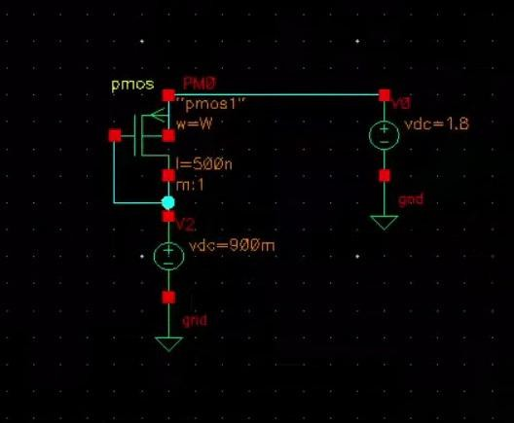**Active Load**

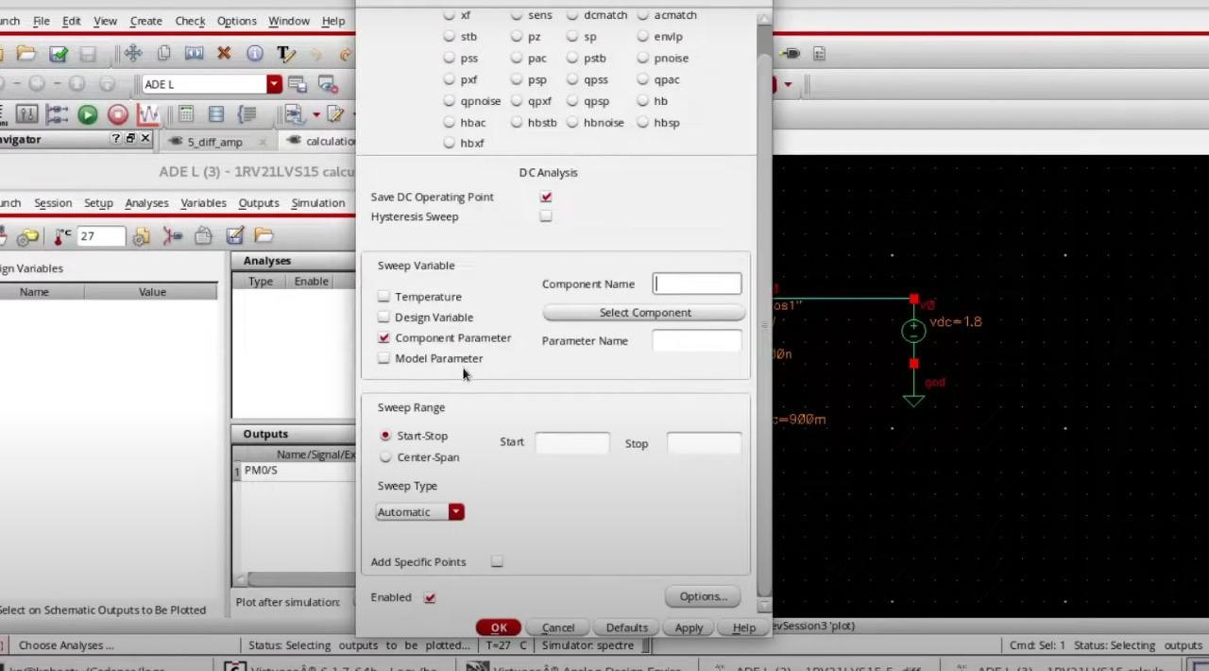

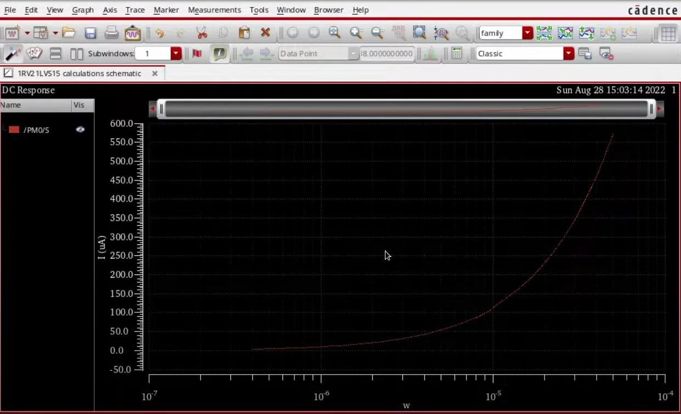

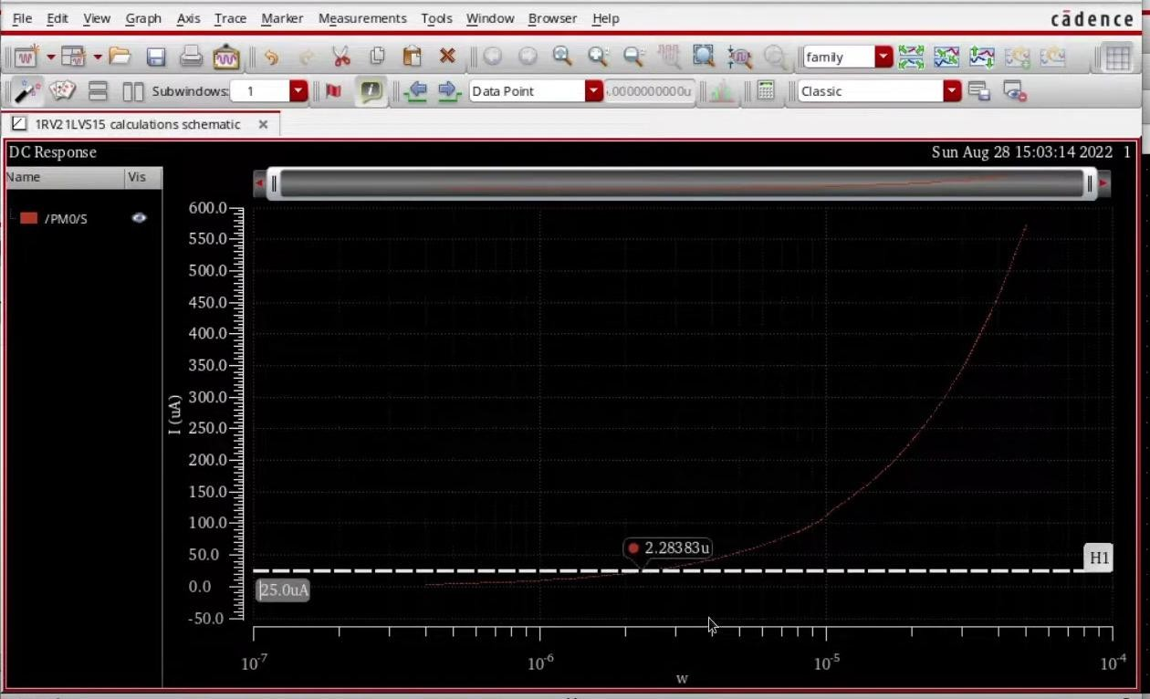

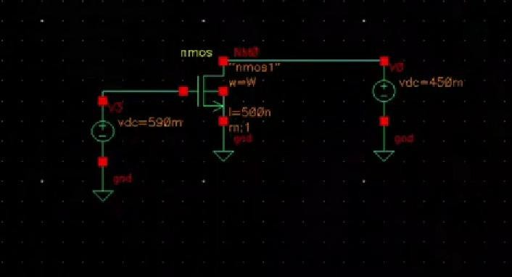

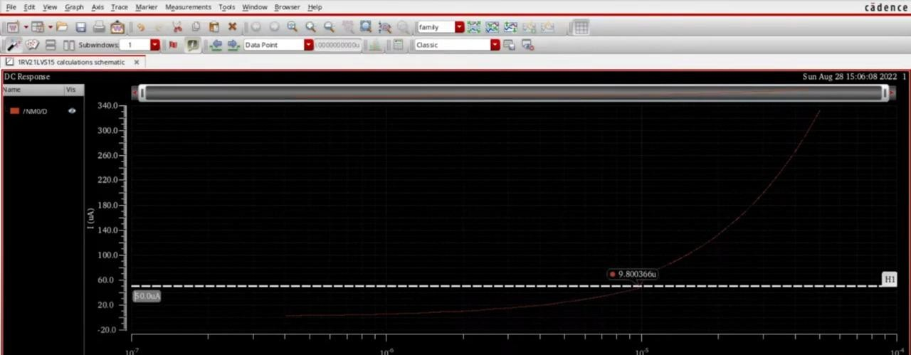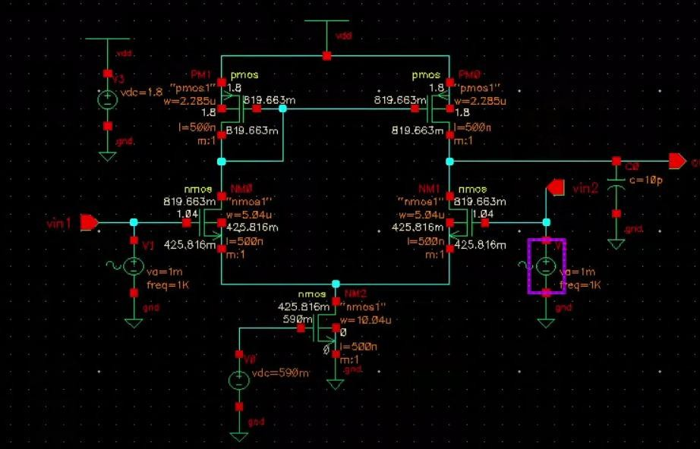

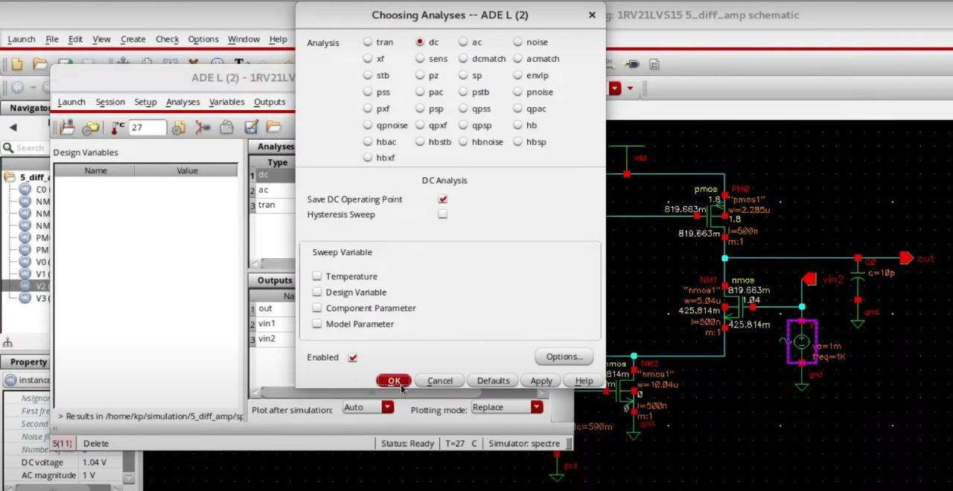

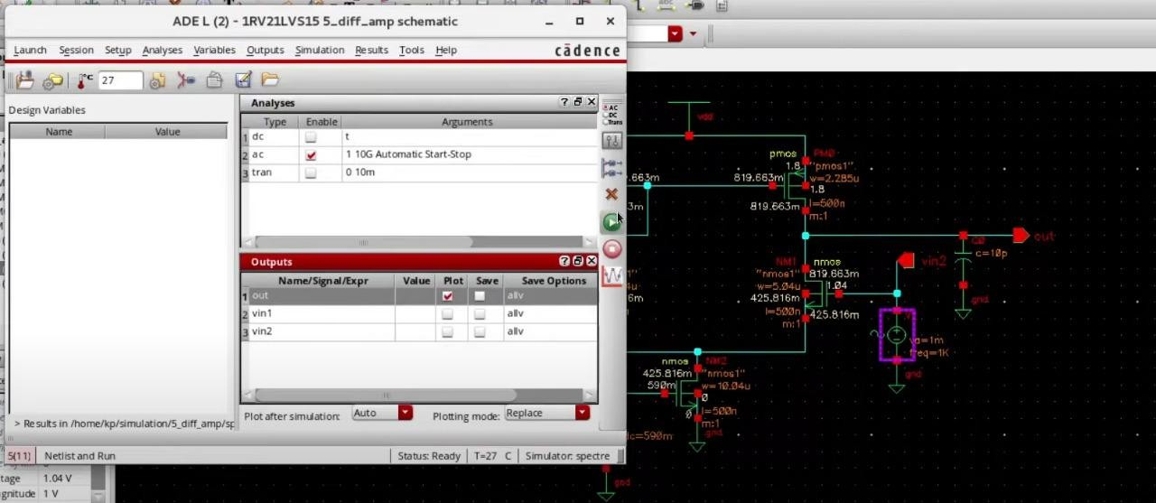

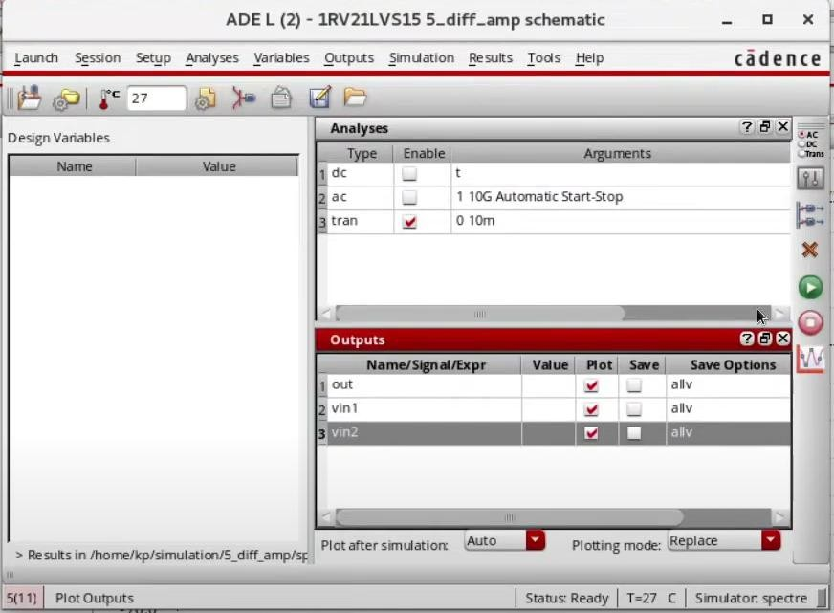

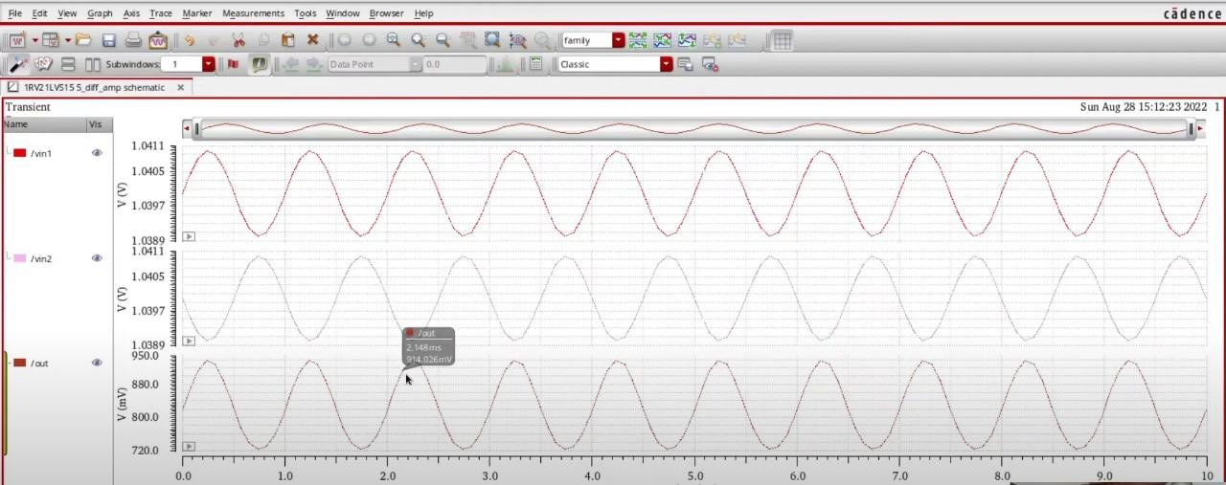

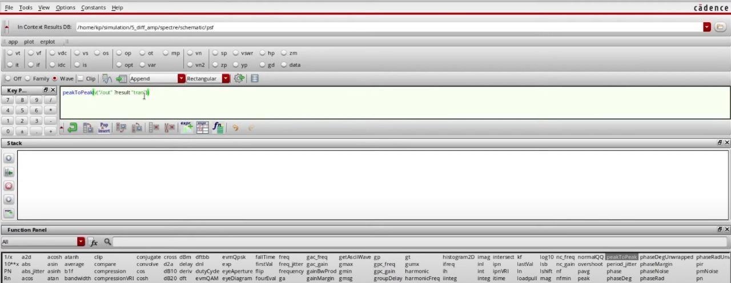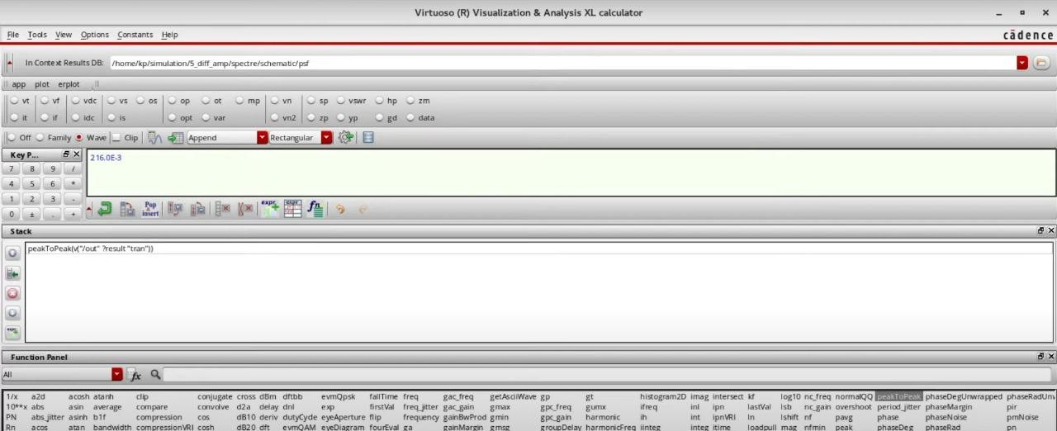

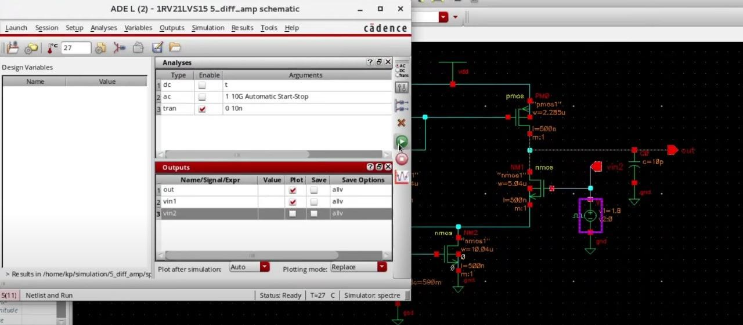

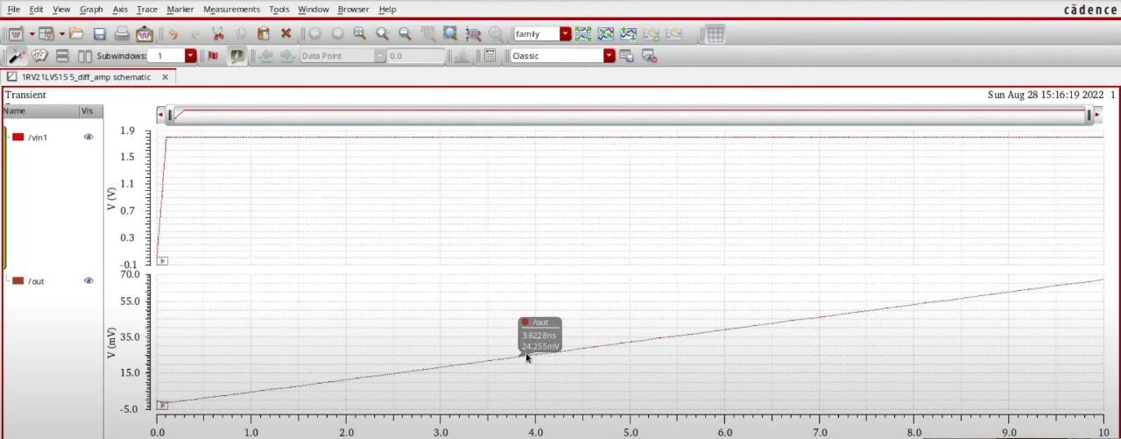

* 1. **Current Source Circuit**

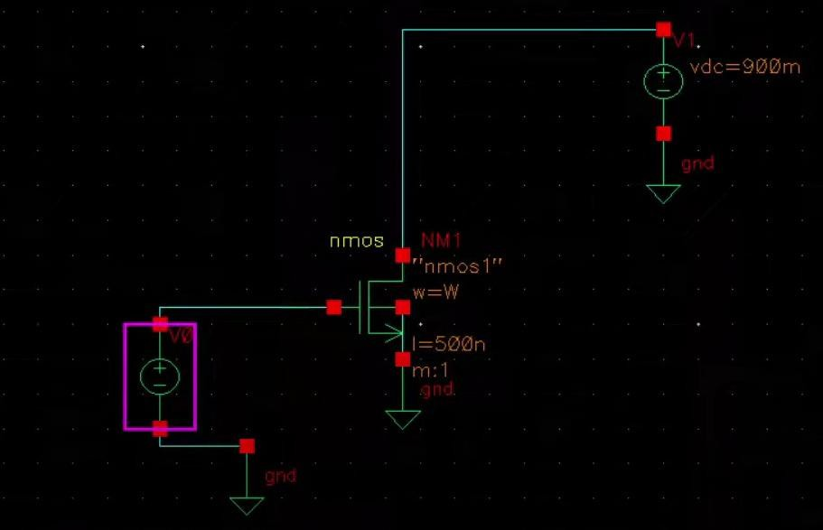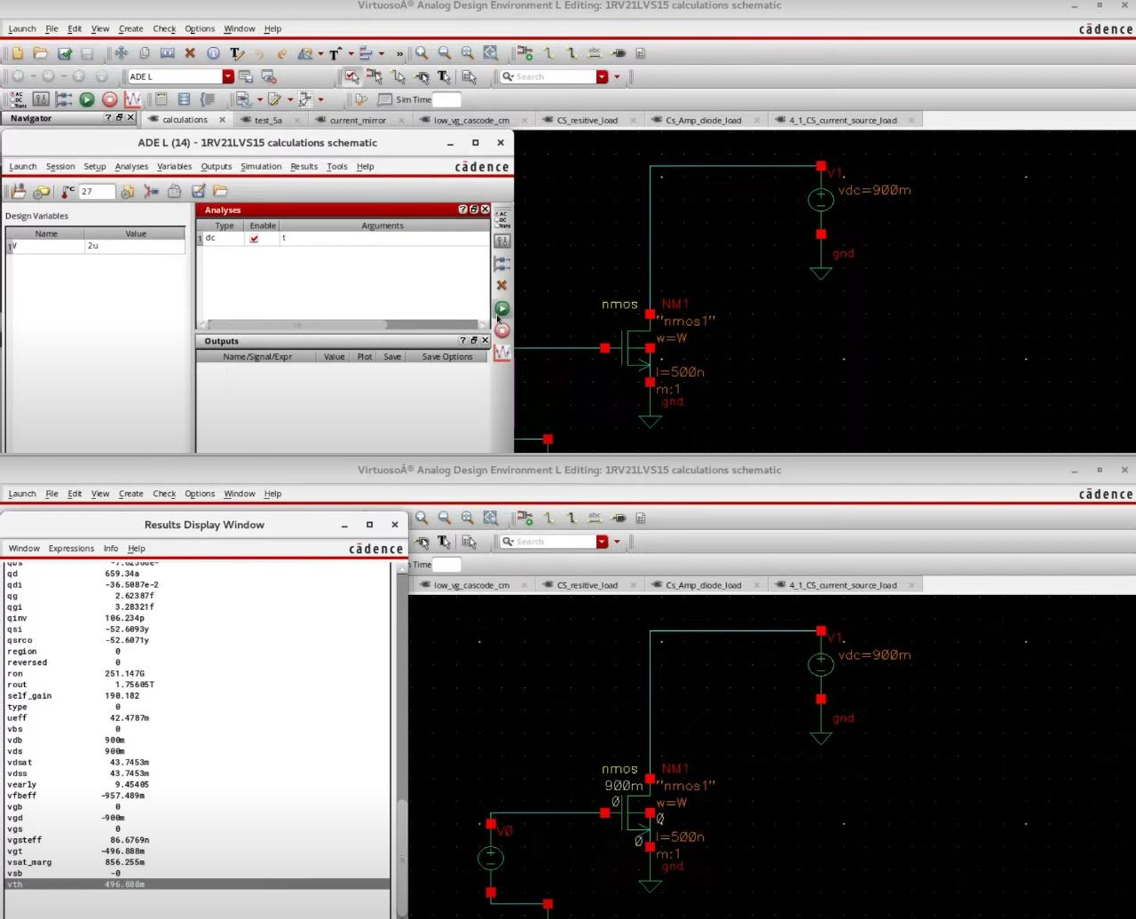

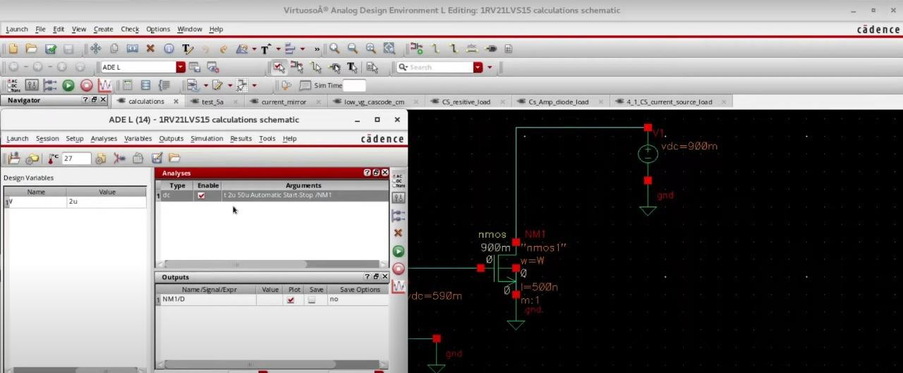

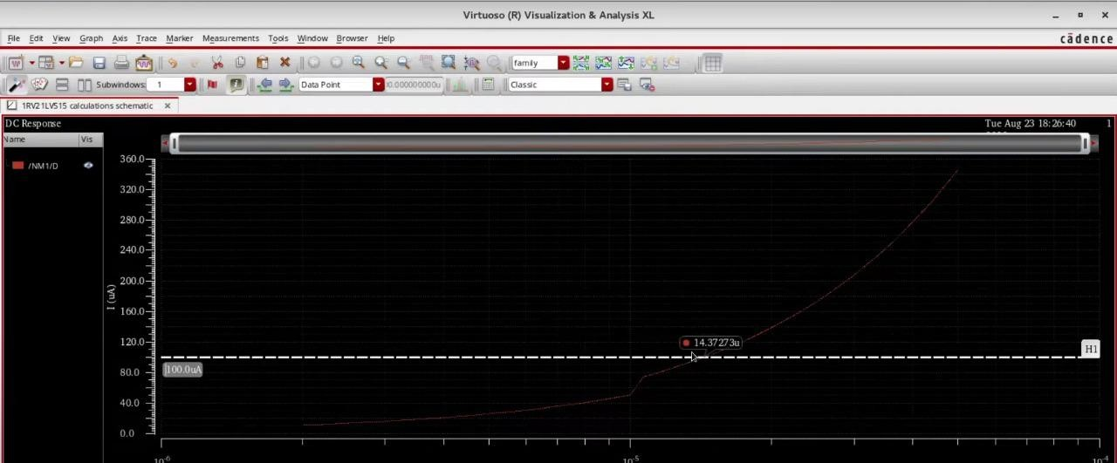

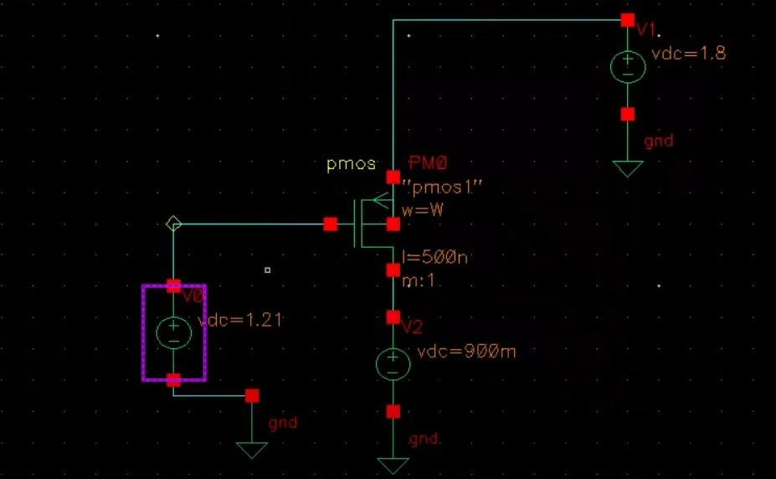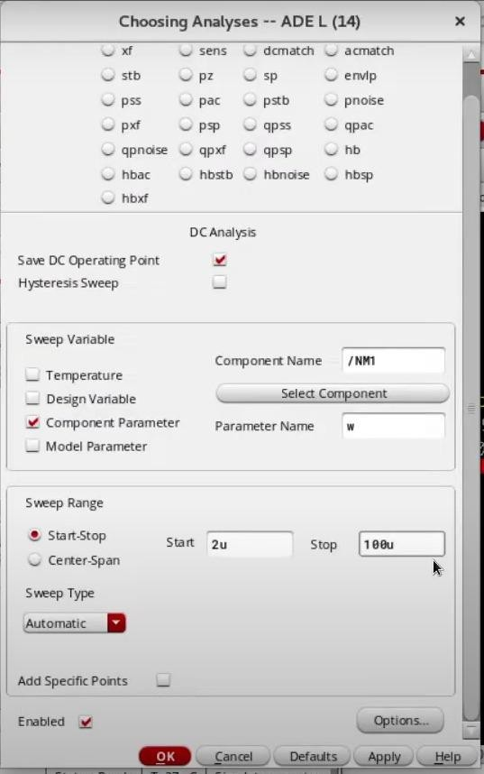

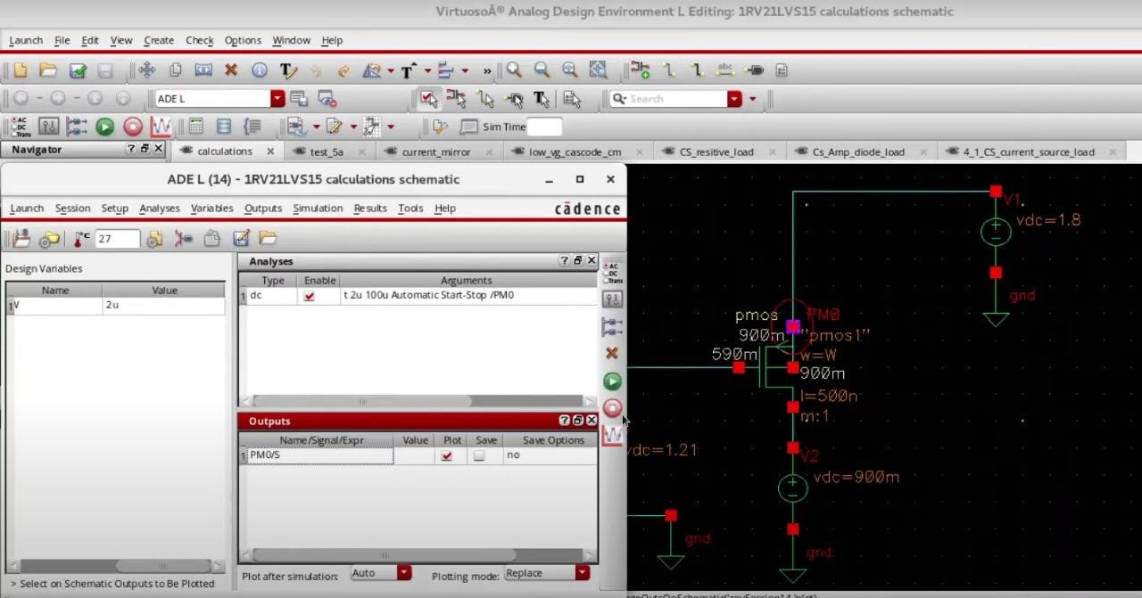

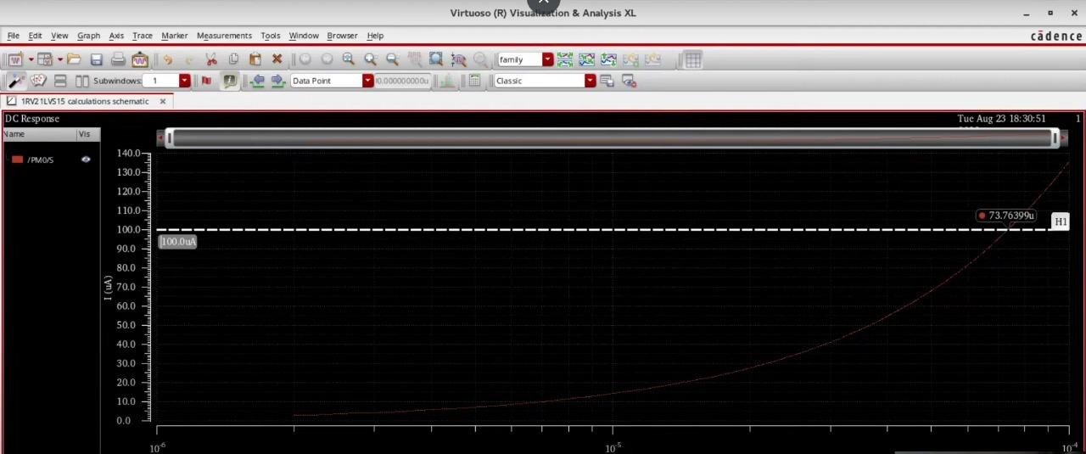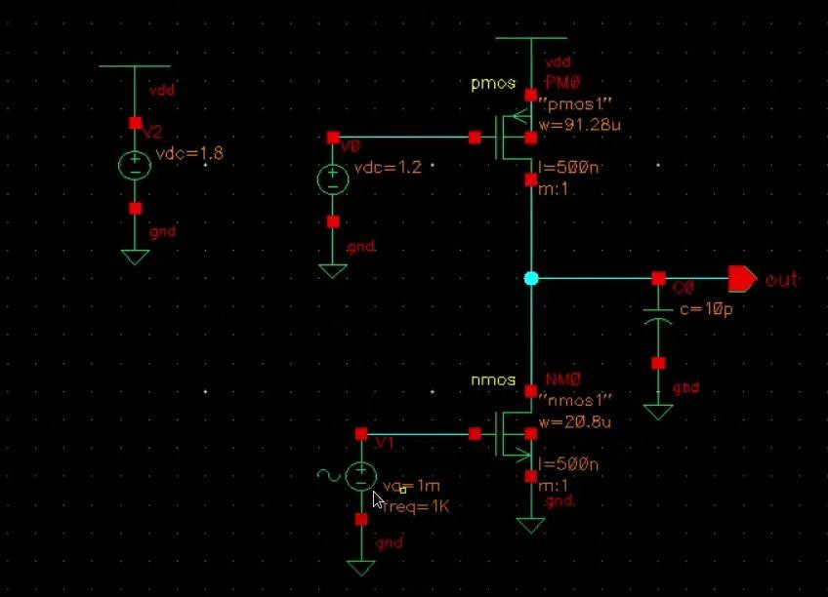

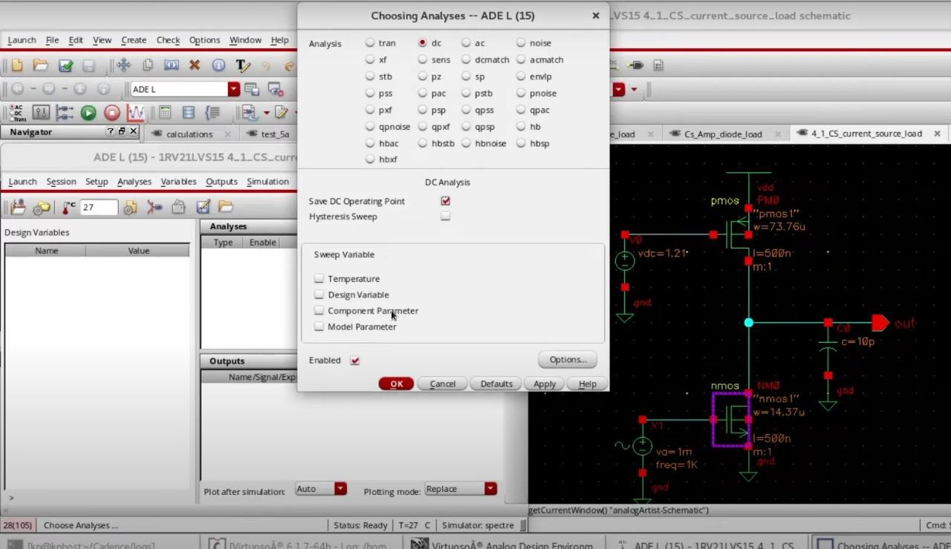

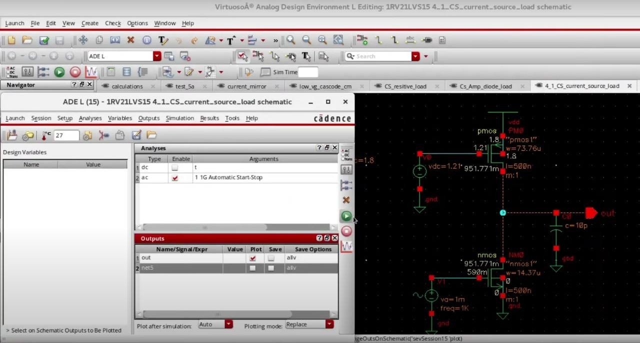

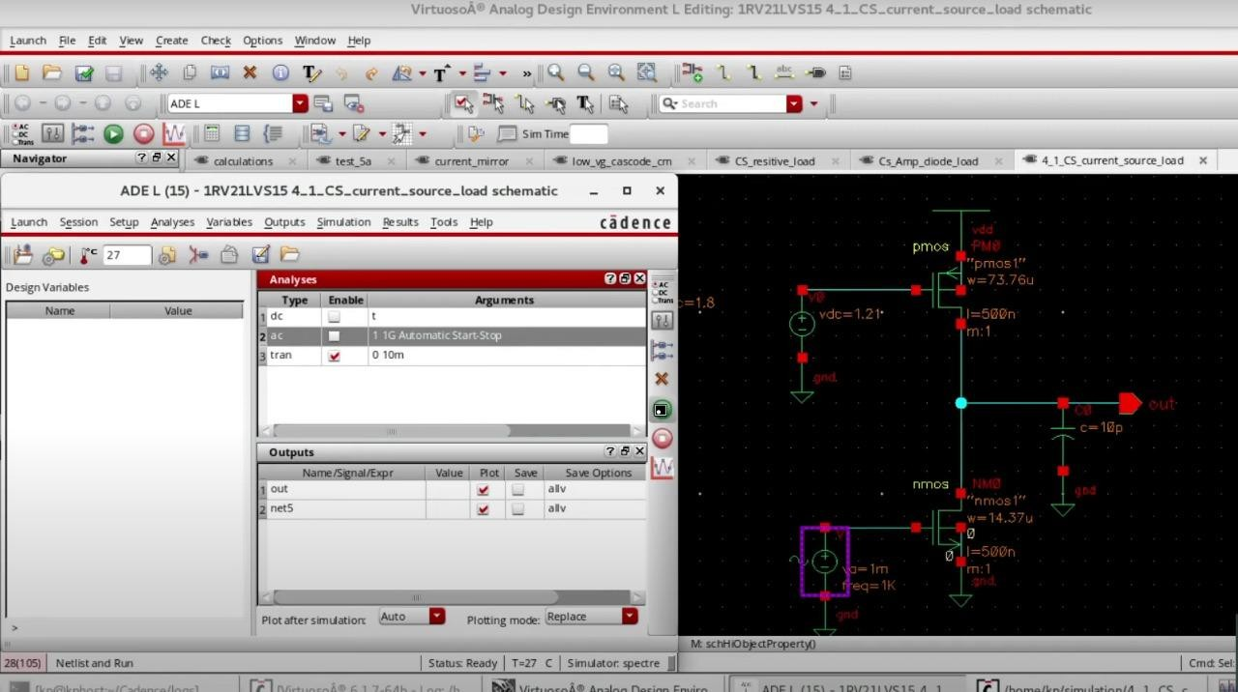

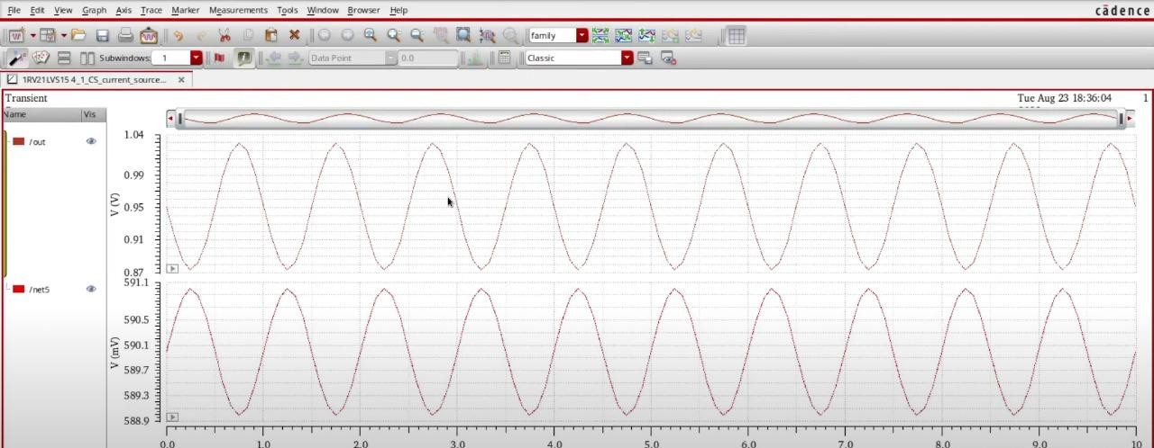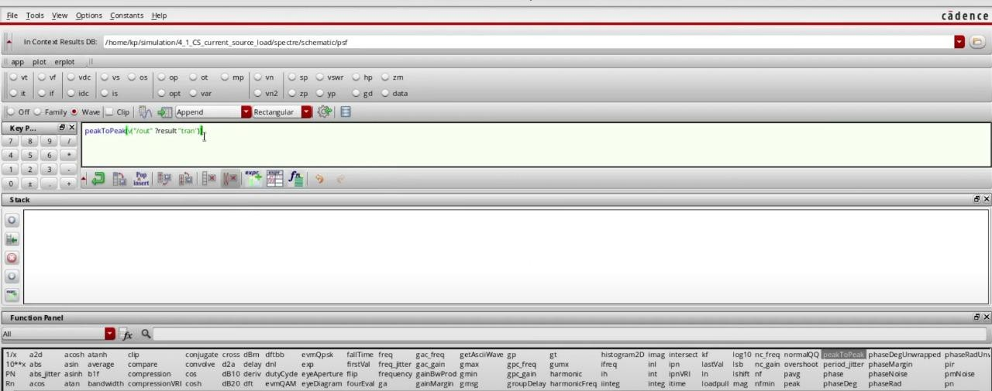

* 1. **Diode Connected Load**

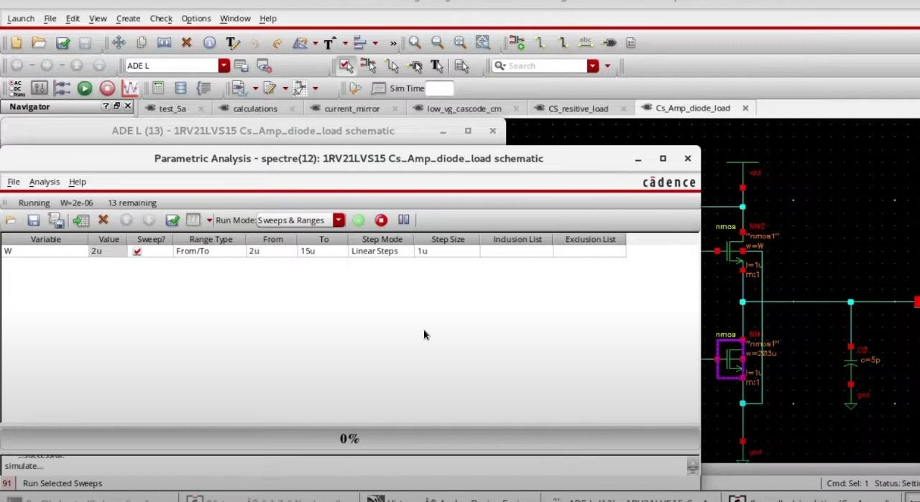

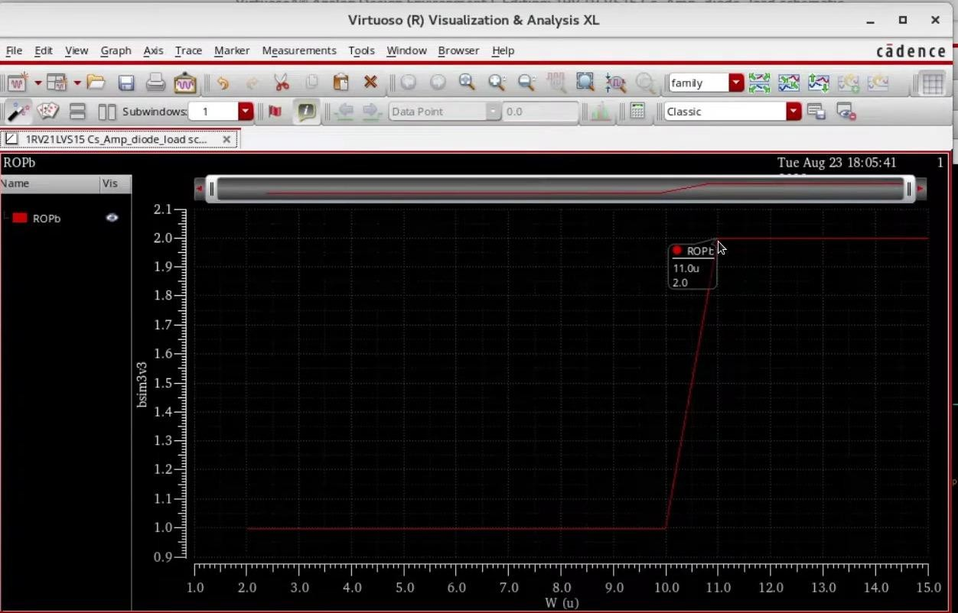

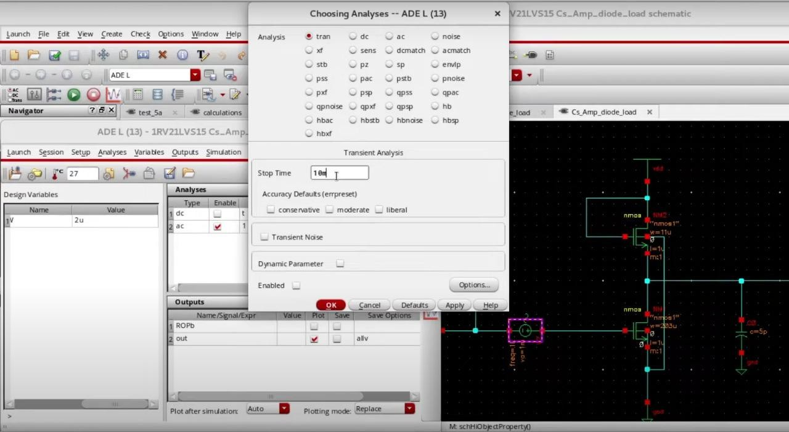

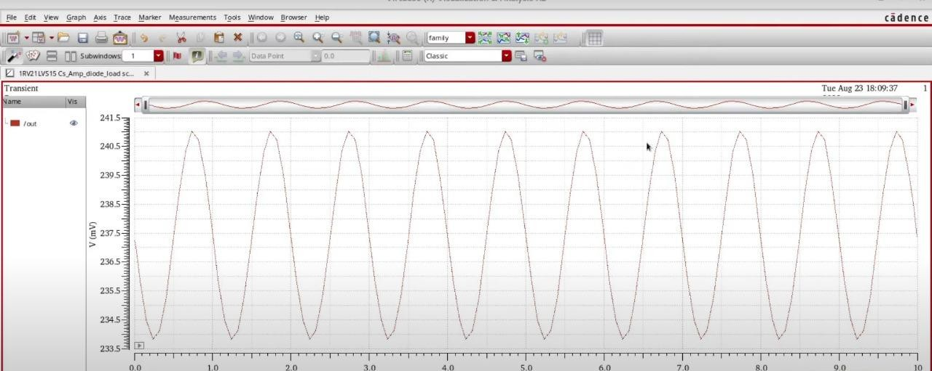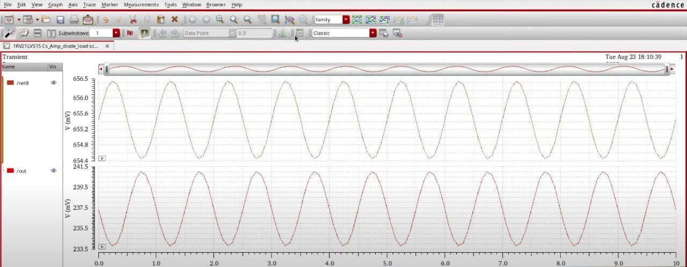

**CHAPTER IV: Circuit Diagram**

* 1. **Active Load**

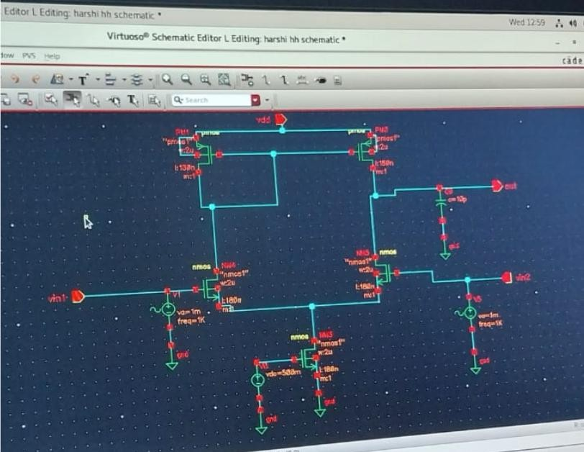

* 1. **Current Source**

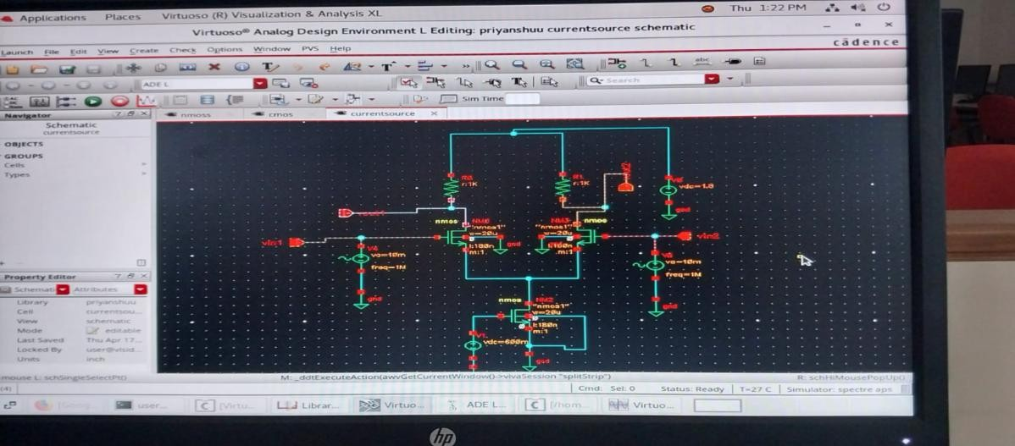

* 1. **Diode Connected Load**

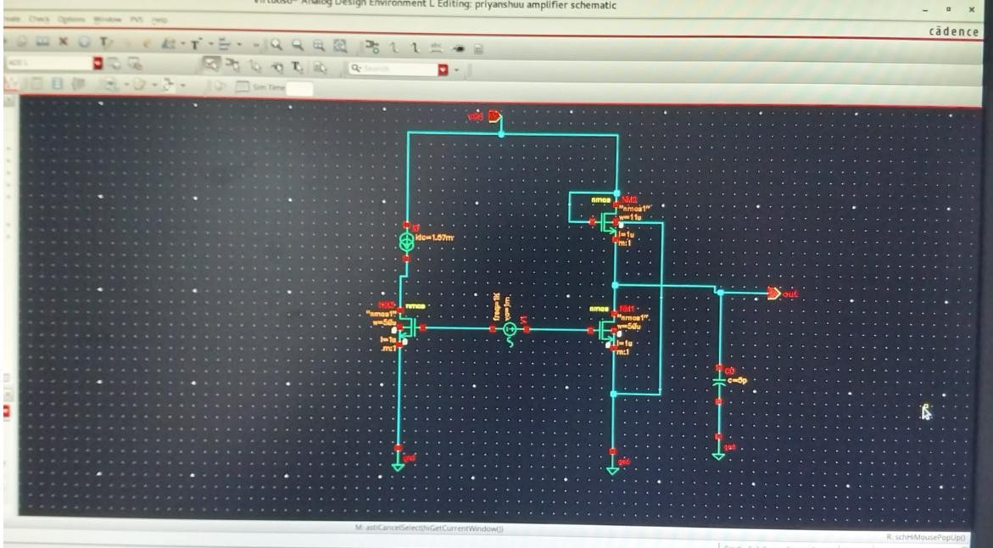

**CHAPTER V: Graphs**

* 1. **Active Load**

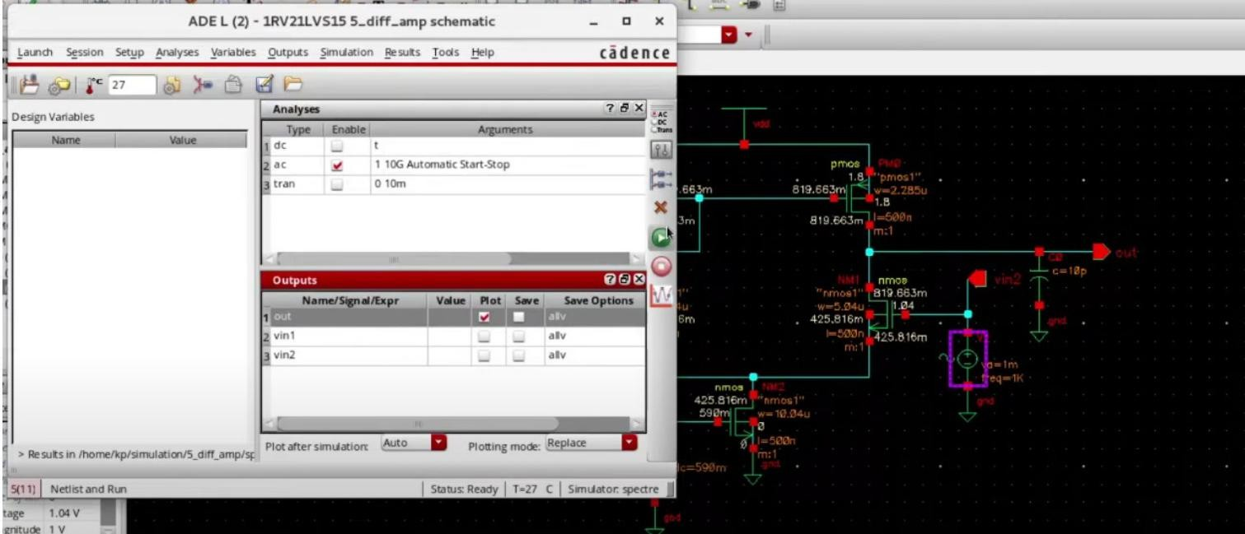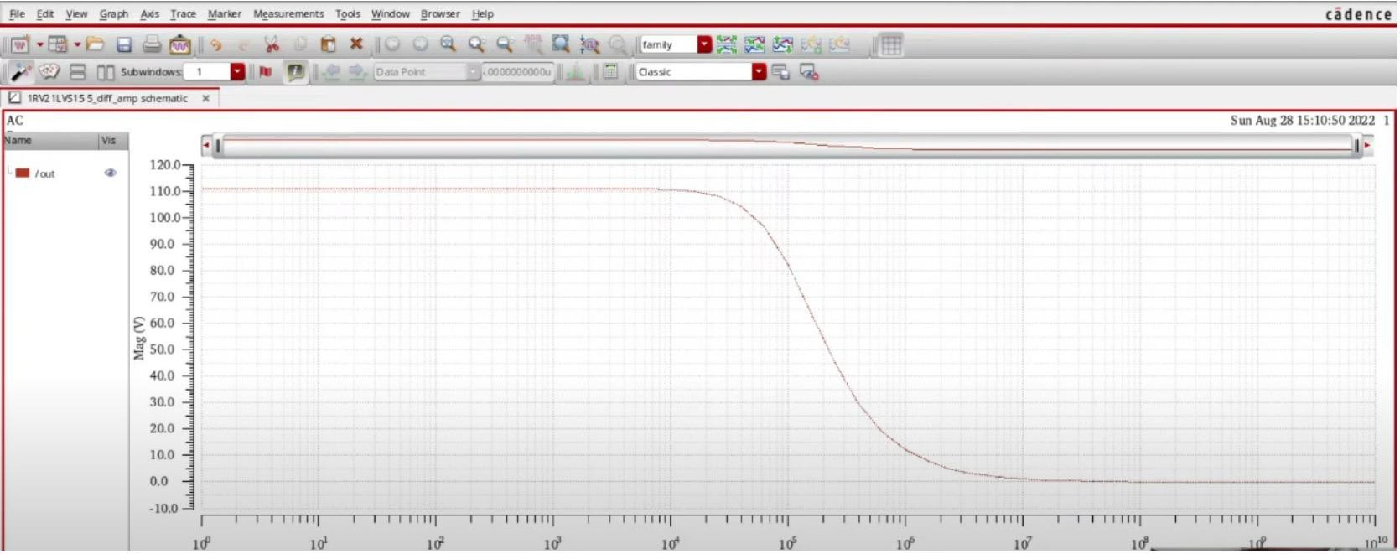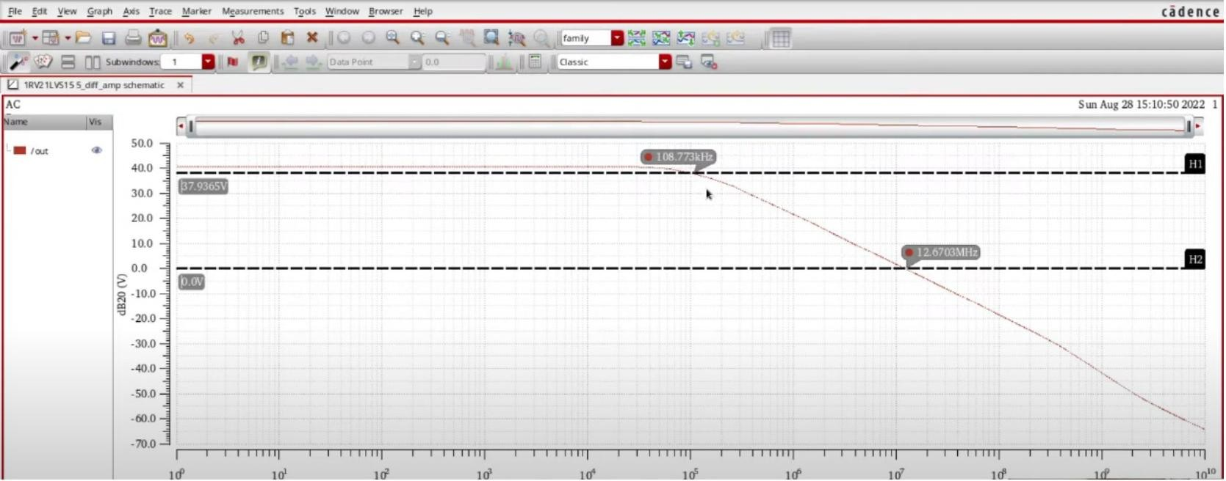

* 1. **Current Load**

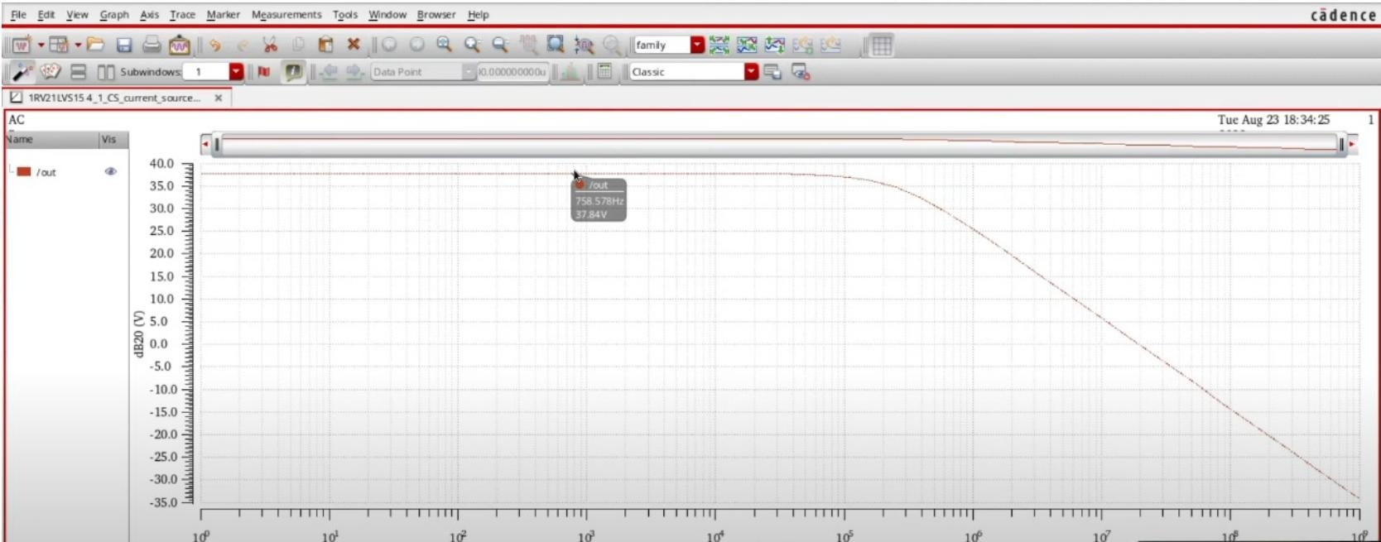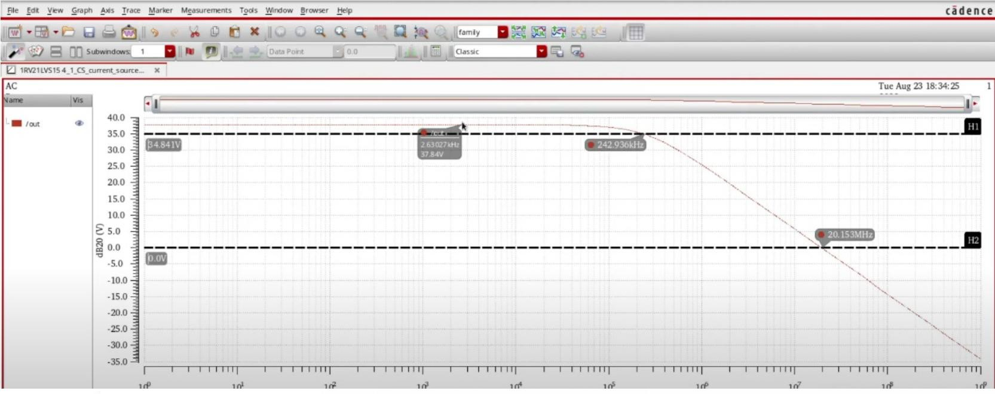

* 1. **Diode Connected Load**

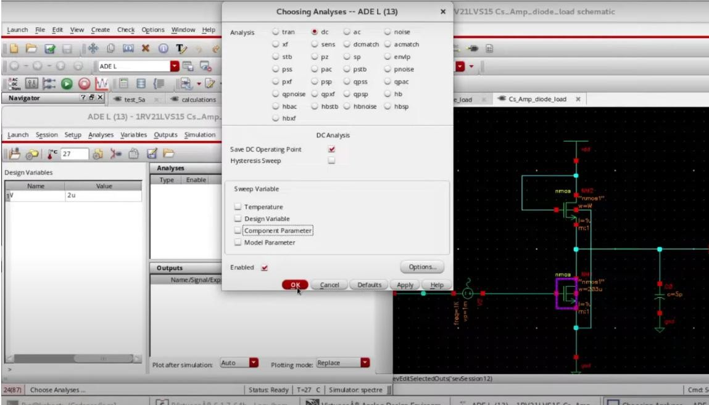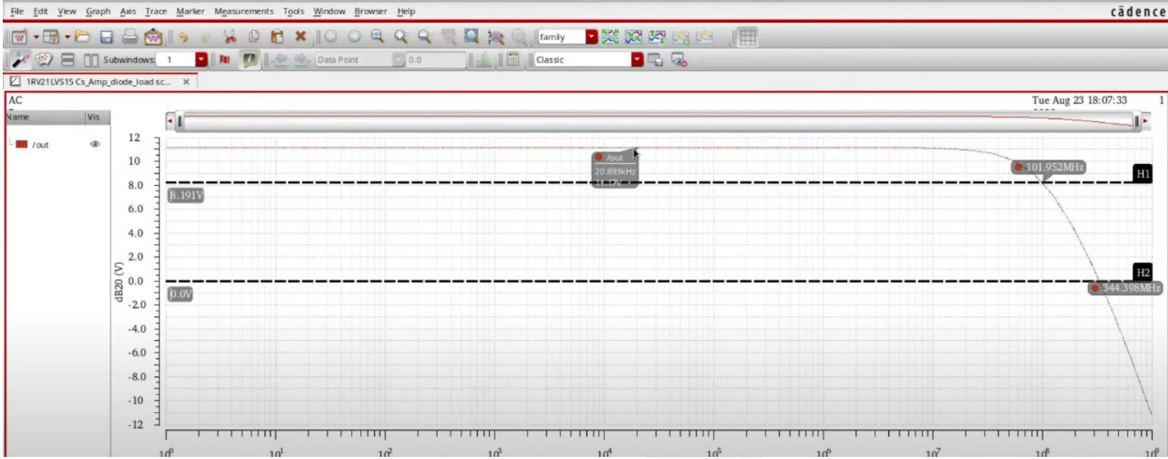

## CHAPTER VI: RESULTS

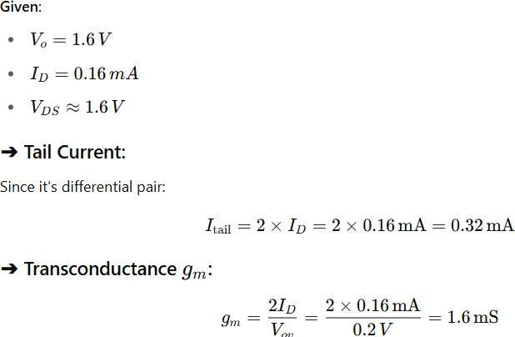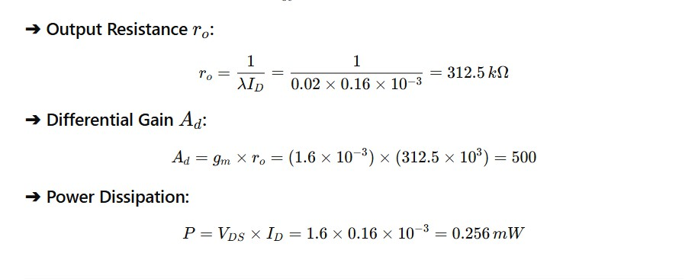

* 1. **Active Load**
  2. **Current Source**

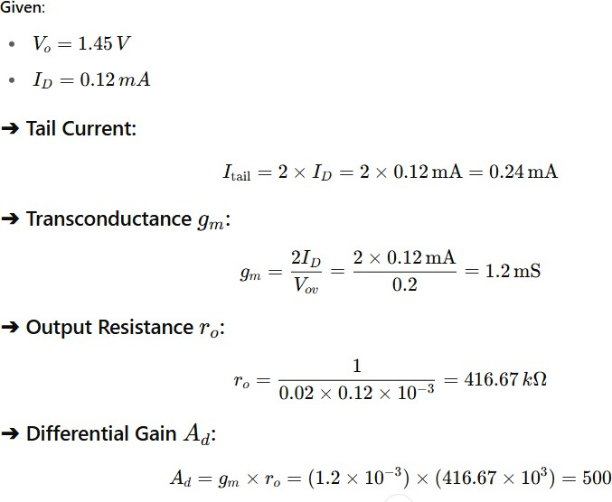



* 1. **Diode connected Load**

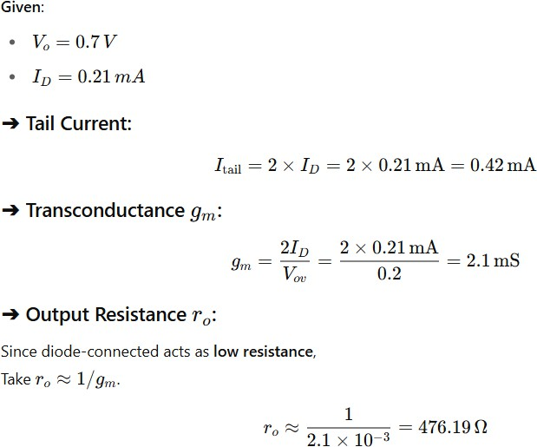

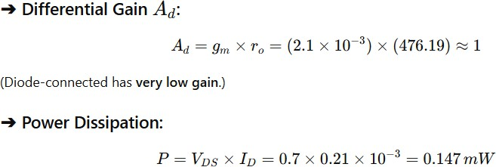



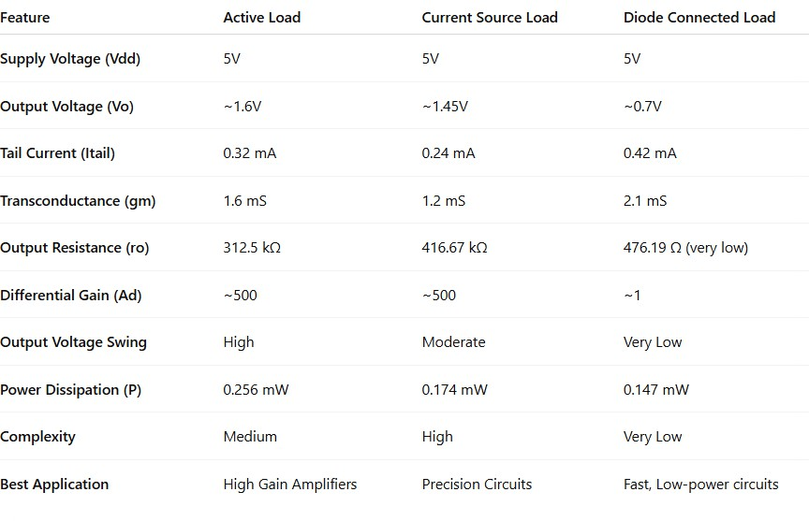

## CHAPTER VI: FUTURE SCOPE

The work on reducing the power consumption of differential amplifiers opens several exciting possibilities for future research and development:

* + 1. **Integration into IoT and Wearable Devices** As the Internet of Things (IoT) and wearable technology sectors expand, ultra-low-power differential amplifiers will be critical. Future designs can focus on creating amplifiers that can operate with nanoampere-level currents while maintaining high precision.
    2. **Advanced Subthreshold Circuit Design** Further exploration into subthreshold and near-threshold circuit operation can lead to even lower energy designs. Techniques to mitigate the performance degradation often seen in subthreshold operation could make this more practical.
    3. **Adaptive and Smart Amplifiers** Development of intelligent amplifiers that dynamically adjust their power consumption based on real-time signal conditions (adaptive biasing, machine-learning-based control) can further enhance efficiency.
    4. **Design for New Semiconductor Materials** With the rise of new materials like **graphene**, **GaN (Gallium Nitride)**, and **2D materials**, future differential amplifier designs can exploit these technologies to achieve even lower power and higher performance than silicon-based designs.
    5. **Low-Power Amplifiers in Biomedical Applications** Power-efficient differential amplifiers have huge potential in biomedical devices like implantable sensors and prosthetics, where battery life and minimal heat generation are critical.
    6. **Radiation-Hardened Low-Power Designs** For aerospace and satellite systems, developing low-power differential amplifiers that are also resistant to radiation effects could be a significant future direction.

## CHAPTER VII: CONCLUSION

The reduction of power consumption in differential amplifiers is an essential step toward building more energy-efficient and sustainable electronic systems. Through the use of optimized biasing, low-voltage operation, advanced circuit topologies like folded cascode structures, and innovative techniques such as subthreshold operation and adaptive biasing, it is possible to significantly lower power usage without major sacrifices in amplifier performance.

This project successfully demonstrates that careful design choices can achieve substantial energy savings, making differential amplifiers more suitable for modern applications such as portable electronics, IoT devices, and biomedical instruments. The outcomes highlight that low-power design is not just a necessity but a vital innovation area for the future of analog and mixed-signal circuit design. Further enhancements, including the use of emerging semiconductor materials and AI-based optimization, can make these systems even more powerful and efficient in the years to come.

**References**

* **Basics of Differential Amplifier** – Electronics Tutorials http[s://www.electronics-tutorials.ws/amplifier/differential-](http://www.electronics-tutorials.ws/amplifier/differential-) amplifier.html

*(Simple explanation with diagrams, ideal for beginners.)*

* **How to Reduce Power in Analog Circuits** – Texas Instruments Blog

https://e2e.ti.com/blogs_/b/analogwire/posts/3-easy-ways-to- reduce-power-in-your-analog-circuit

*(Very easy tips on reducing power consumption in any analog design.)*

* **Differential Amplifier Explained Simply** – All About Circuits [https://www.allaboutcircuits.com/technical-articles/the-](https://www.allaboutcircuits.com/technical-articles/the-differential-amplifier/) [differential-amplifier/](https://www.allaboutcircuits.com/technical-articles/the-differential-amplifier/)
* B. Razavi, “Design of analog CMOS integrated circuits,” McGraw- Hill Education, 2001.
* C. C. Enz and G. C. Temes, “Circuit techniques for reducing the effects of op-amp imperfections: autozeroing, correlated double sampling, and chopper stabilization,” *Proceedings of the IEEE*, vol. 84, no. 11, pp. 1584–1614, Nov. 1996.

(Deals with improving precision and reducing power.)